1. **How to install ansible?**

**# yum install epel-release**

**# yum install ansible**

**# ansible --version (to confirm installation)**

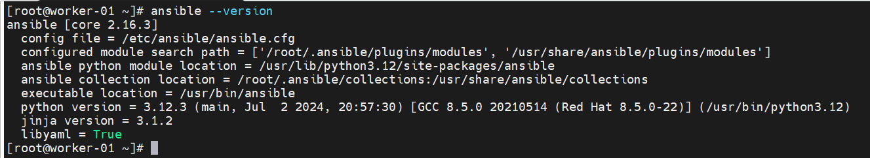

1. **Here, we are using target machine is ubuntu. The first prerequisite in ansible is that you should able to login target machine without password. i.e. password less login. To achieve this, we have to generate public key on ansible server (source machine).**

**# ssh-keygen**

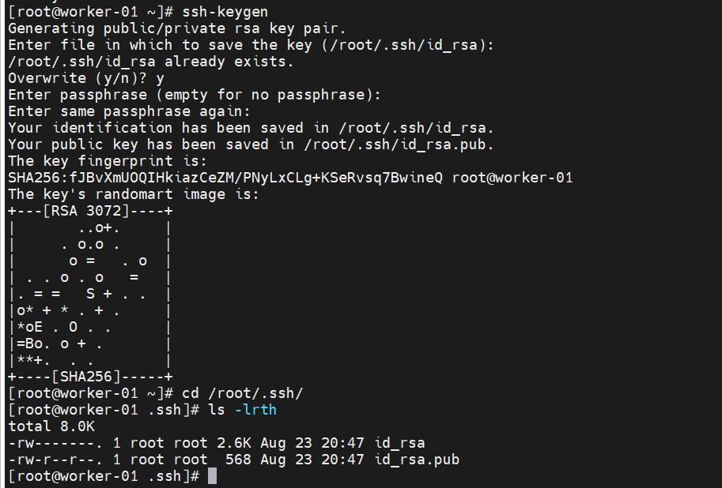

1. **Perform same step on target machine as well.**

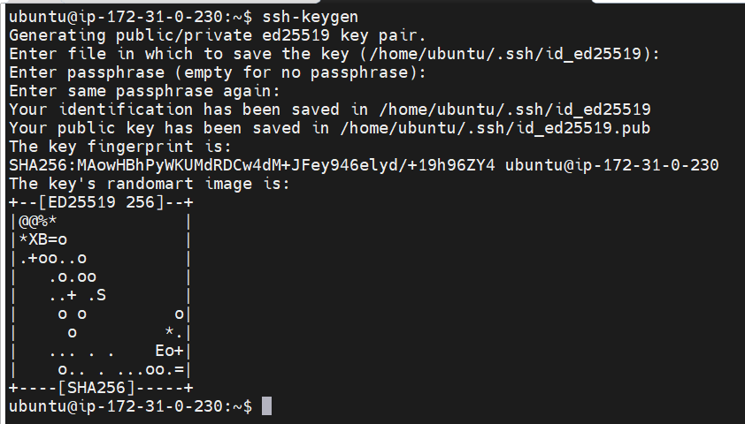

1. **Now copy source machine pub key and add it into target machine authorized key file. That’s it you can now login to target machine without password.**

